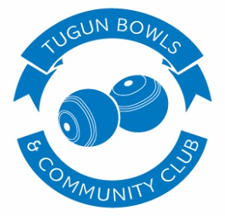
BECOME A MEMBER
MEMBERSHIP APPLICATION

Social Member $7.50 | Bowling Member $130.00 | MEMBER#______

MR MRS MS First Name _________________ Surname ___________________

DOB ______/______/______ Drivers Licence Number _________________

Phone Number ____________ Email Address _________________________

Residential Address _______________________________________________

Suburb _____________________ State __________ Postcode ___________

Applicant’s Signature _____________________ Date ______/______/_____

ID Verified by Staff Member ________________ Date ______/______/_____

BOWLING MEMBER APPLICANTS TO COMPLETE BELOW

Are you or have you been a member of another bowls club? YES NO
If YES, name and address of club ___________________________________________________________

Have you ever been suspended or expelled from any bowls club? YES NO
If YES, name and address of club ___________________________________________________________

If you are or have been a member of another bowls club
have you fulfilled all of your financial obligations? YES NO

Are you? An Umpire YES/NO Cert. No. _____________Exp ____/____/____
A Coach YES/NO Cert. No. _____________Exp ____/____/____

NOTE: This application cannot be finalised without a clearance from your present club and it is the applicants responsibility to arrange that clearance.

Proposers Name ______________________________________ Membership No. ____________________
Proposers Signature ______________________________
Seconders Name ______________________________________ Membership No. ____________________
Seconders Signature ______________________________

By becoming a member of Tugun Bowls & Community Club Inc. you agree to abide by the rules & regulations enforced by the club. The Tugun Bowls &
Community Club Inc. is committed to the privacy of your personal information supplied on this form under the Queensland Club Industry Privacy Act.
By providing your details you have agreed to receiving marketing and promotional material from the Tugun Bowls & Community Club Inc.
You may opt out at any time via opt out options provided in the material or by contacting the Club. The club issues special offers from time to time
to members using various forms of correspondence, noting it remains the members responsibility to confirm the accuracy of all details.

